**HARP Phantom Specifications and Usage**

Version 1.6 of the HARP Phantom

# Overview

The purpose of this project was to develop an open-source 3D-printable phantom which allows for the measurement of the axial modulation transfer function (MTF) for CT and cone-beam CT (CBCT) systems. The phantom is readily available for download as STL files.

The folder contains CAD files for the top and bottom plates as well as posts and columns of varying heights. The plates can accommodate either wires or posts for point and edge spread functions respectively. The phantom can easily be incorporated into the CATPHAN(T) 500 and 600** and parameters such as height and wire rotation can be modified to create a range of point spread functions. Up to 25 wires can be strung through the phantom and at most 25 posts can be inserted for numerous modulation transfer functions per scan.

# Components

## Plates

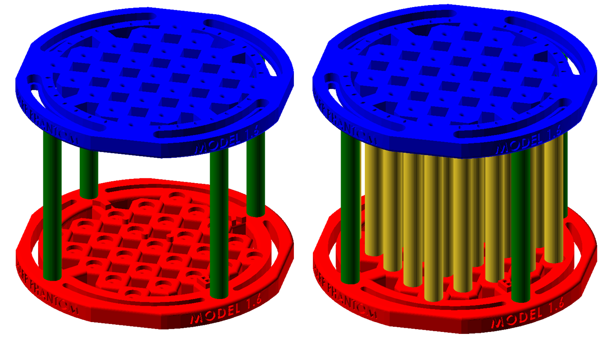

Figure 1. Individual STL files of the phantom. The blue component represents the top plate (Top_Plate.STL), while the red is the bottom plate (Bottom_Plate.STL). The green represents the columns (Column_10cm.STL, Column_6cm.STL, Column_3cm.STL) and the yellow are the posts (InnerPost_10cm.STL, InnerPost_6cm.STL, InnerPost_3cm.STL) used for the edge spread function.

The full diameter of the top and bottom plates, colored blue and red respectively in Fig. 1, is 150 cm, which corresponds to the diameters of the phantom sections for both the CATPHAN 500 & 600. The thickness of each plate is 10 mm, making the total height either 120 mm, 80 mm, or 50 mm depending the columns and innerposts used. The front side of the plates is the side with the letters, and when fully assembled, the front and back plates face each other. The letter “T” and “B” shown in Fig.2 (4) denote the top and bottom plates respectively. In Fig. 2 (1), the “X” and “Y” indicate the positive X and Y axes when the plates face each other. The three small cylindrical nubs in Fig. 2 (2) serve as fiducials. Both the “X” and “Y” and the fiducials can be visible in the CT in order to properly orient the images.

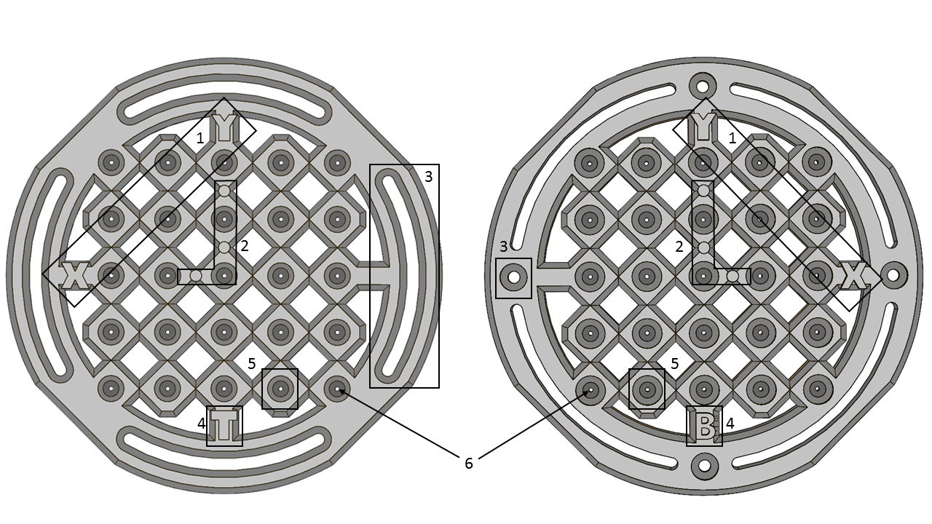

Figure 2. Labeling parts of the top (left) and bottom (right) plates. 1- Positive X and Y axes. 2- Fiducials. 3- Column inserts. 4- Top or bottom plate indicators. 5- Innerpost insert. 6- Wire clearance hole.

The diameter of the wire clearance hole shown in Fig. 2 (6) is 1.50 mm which is suited for wires of 15 Gauge and larger. The 25 wire and column holes fit inside a 77.78 x 77.78 mm square, where the vertices of the square are at the center of the holes. The edges for each wire clearance hold have been smoothed out to ensure that the wire will not break. The columns are inserted near the edge of the plates shown in Fig. 2 (3) and the posts are inserted in the holes labeled as “5” in Fig. 2. The depth of each column or post hole is 2.5 mm. The distance between two adjacent wires is 19.45mm while the distance between two diagonal wires is 27.50mm. The space between two adjacent columns is 16.50 mm while the space between 2 diagonal columns is 8.45mm. The measurements between the posts and the wires is the same for both the top and bottom wires shown in Fig. 3. The diameter of the post and column insert is 9 mm, but the diameter of the actual post and columns is 10mm, which is why Fig. 3 has the dotted lines.

|  |  |  |
| --- | --- | --- |
|  | Letter | Dimensions |
| A | 19.45 mm |
| B | 16.50 mm |
| C | 27.50 mm |
| D | 8.45 mm |

Figure 3. The distances between wires are posts. “A” represents the distance between two adjacent wires. “C” is the distance between two diagonal wires. “B” is between 2 diagonal posts, and “D” between two adjacent posts. The dotted circles indicate the volume of the post.

**Top_Plate.STL**: A key difference between the top and bottom plates is where the screws are inserted for the columns. Notice in Fig. 2 (3) the top plate has arcs while the bottom plate has circular inserts. In order to be able to rotate the wires, the top plate rotates along the z axis while the bottom plate remains still. On the front side of the top plate, the columns attach at the arcs, which are 65 mm from the center of the plate. The screw goes in from the back of the plate and the column connects at the front of the plate.

On the back side of the top plate, the debossed ovals represent rotations by 10 degrees going from measurement “M” to “N” in Fig. 4, where “M” in the center indicating a 0 degree rotation. At most a 30 degree to either side can be applied indicated by “O.” A rotation happens when the top plate is rotated about the z-axis and the screw slides along the arc. 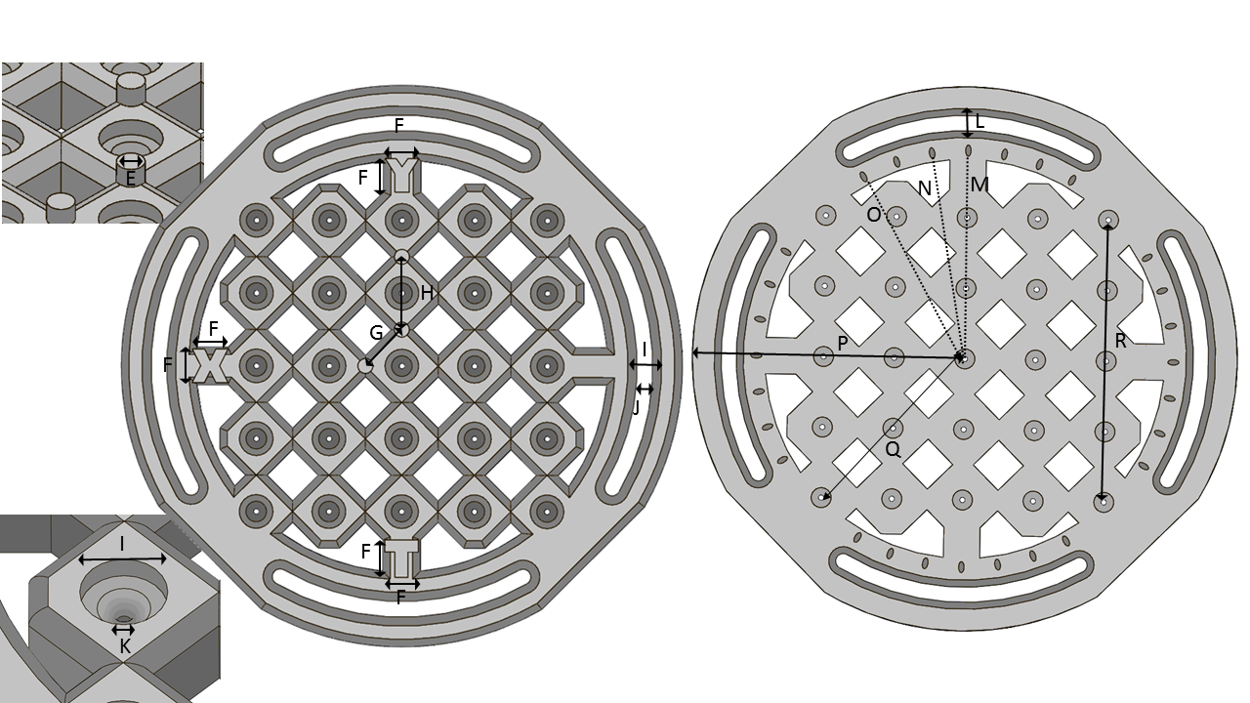

Figure 4. Top plate front and back measurements.

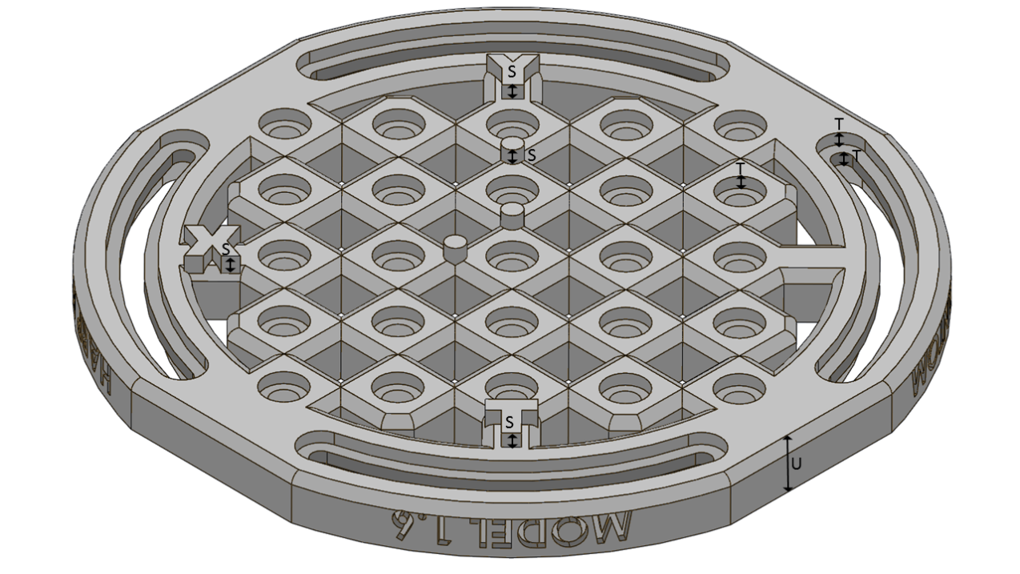

Figure 5. View of the angled front side of the top plate.

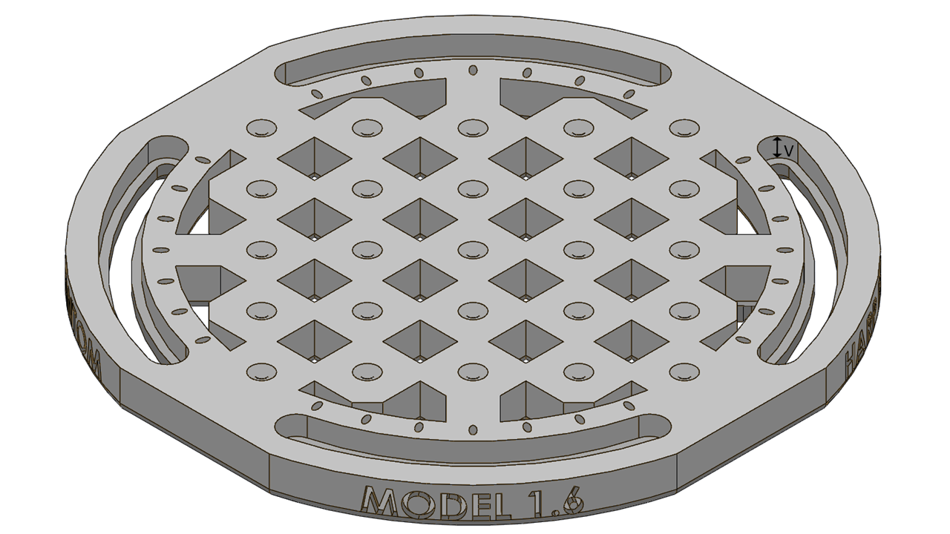

Figure 6. Angled view of the back side of the top plate.

|  |  |  |  |  |
| --- | --- | --- | --- | --- |
| Letter | Dimension |  | Letter | Dimension |
| E | 4mm |  | N | 10° line |
| F | 9mm |  | O | 30° line |
| G | 13.75mm |  | P | 75mm |
| H | 19.45mm |  | Q | 55mm |
| I | 9mm |  | R | 77.78mm |
| J | 4.17mm |  | S | 3mm |
| K | 1.50mm |  | T | 2.5mm |
| L | 8mm |  | U | 10 mm |
| M | 0° line |  | V | 5mm |

Table 1. This table gives the measurements for the top and bottom plates corresponding to Fig.4-9.

**Bottom_Plate.STL:** The screws are inserted in hole “3” from Fig. 2. Unlike top plate, the screws for this plate remain stationary. While its diameter of the arcs is 4.17mm, there is no clearance for either the column or the screw cap. The arcs in the bottom plate are strictly decorative.

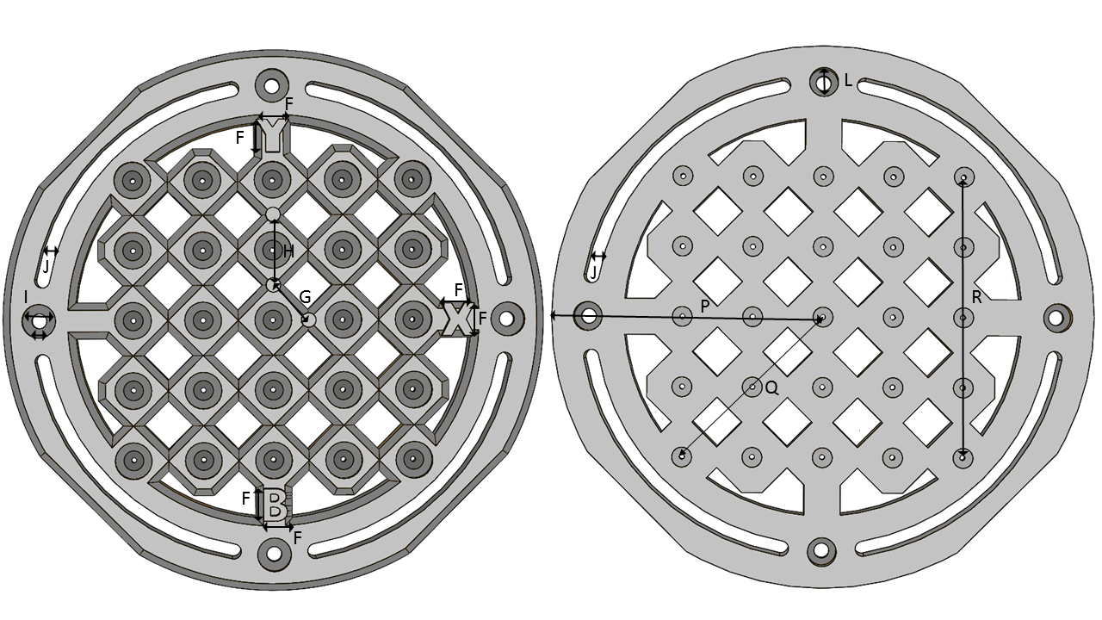

Figure 7. Front and back plates of the bottom plate. The measurements are the same as the ones for the top plate.

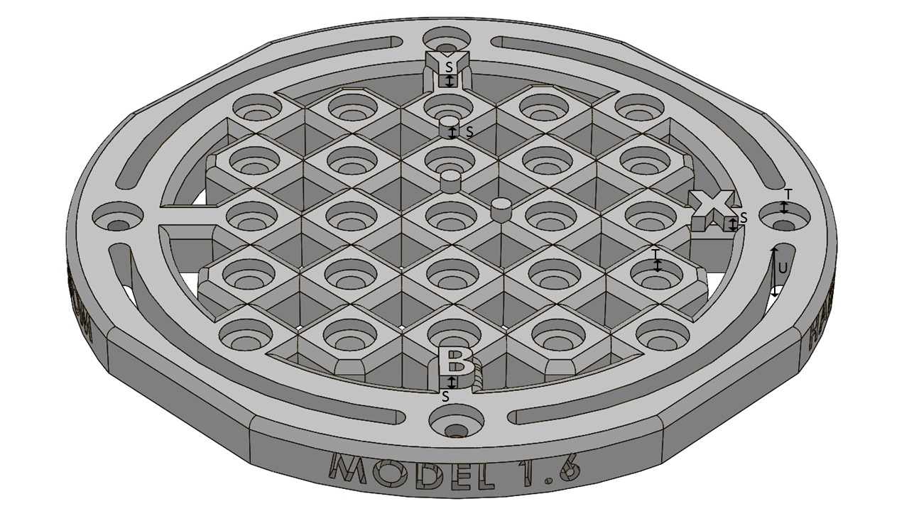

Figure 8. The front side of the bottom plate.

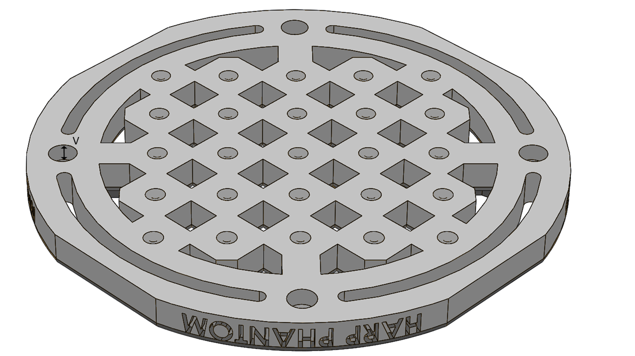

Figure 9. The back side of the bottom plate.

## Columns and Posts

Both the columns and the posts come at 3 different lengths, 10cm, 6cm, and 3cm. The key difference between the two is that the column has 2 threaded holes at both ends for the screw, while the posts do not. The posts and columns are 10 mm in diameter, except at the ends where they are 9 mm. The 10 mm diameter represent the actual height of the post or column while the 9 mm portions are inserted into the plates at a 2.5 mm depth. The fully assembled with the assorted height can be seen in Fig. 11.

**Column_10cm.STL, Column_6mm.STL, Column_3mm.STL:** The 4 columns sit near the edge of the plates and are responsible for holding a certain distance between the top and bottom plates. Plastic screws are used to keep the columns in place. The threaded hole for the screw is designed to accommodate an 8-32 screw and each height has a varying depth from ½ in, ¾ in, and 1 in for the 3cm, 6cm, and 10cm heights respectively.

|  |  |
| --- | --- |
| a) | b) |

Figure 10. Column and innerpost measurements. 10(a) shows the columns measurements specifically while 10(b) shows the posts.

|  |  |  |  |  |
| --- | --- | --- | --- | --- |
| Letter | Dimension |  | Letter | Dimension |
| W | ½ in |  | AB | 100mm |
| X | ¾ in |  | AC | 9mm diameter |
| Y | 1in |  | AD | 10mm diameter |
| Z | 30 mm |  | AE | 2.5mm |
| AA | 60mm |  | AF | 4.17mm |

Table 2. Measurements for the columns and posts corresponding to Fig. 10.

The recommended screw for the clearance is a ¾-1 inch 8-32 plastic screw with a hex or Philips head, specifically the ¾ in 8-32 Philips head (Manufacturer No: XXXXXX) from XXXXXX.

**Innerpost_10cm.STL, Innerpost_6mm.STL, Innerpost_3mm.STL:** The posts are designed the same way as the columns, except they have no clearance holes for the screws. They are inserted into hole “5” from Fig.2 Up to 25 posts can be placed into the HARP Phantom in order to find the edge spread function. Unfortunately the posts cannot be rotated so the top plate has to be aligned with the 0 degree line “M” from Fig. 4.

|  |  |
| --- | --- |
| a)  https://lh4.googleusercontent.com/tpEJGuIunnlxWQrw1_aFFXzVy8OKNh_VvGlPV3XIeawRrnEoGn0XQMyXx3sjaQ2_B_w00QMEdct3Z6zutGdMyWDXVXGpFr-VOto2L1wIORch_h5mNyEngaw-OKAZhp54ucNf6eVn | b)  https://lh4.googleusercontent.com/tpEJGuIunnlxWQrw1_aFFXzVy8OKNh_VvGlPV3XIeawRrnEoGn0XQMyXx3sjaQ2_B_w00QMEdct3Z6zutGdMyWDXVXGpFr-VOto2L1wIORch_h5mNyEngaw-OKAZhp54ucNf6eVn |
| c)  https://lh3.googleusercontent.com/m9fJWEE70K2teWV3WHsKNCyezXO5XPE4pfHcEv3Docp9RmpYD5DnOuqIJpm7a2i1RlXhsugBMOqiINbCFkOFn5ODcizZ7FYb5a_Amlq7rgTl-JzbJnE9OfCgke0zWYC74eCrqFzi | d)  https://lh3.googleusercontent.com/m9fJWEE70K2teWV3WHsKNCyezXO5XPE4pfHcEv3Docp9RmpYD5DnOuqIJpm7a2i1RlXhsugBMOqiINbCFkOFn5ODcizZ7FYb5a_Amlq7rgTl-JzbJnE9OfCgke0zWYC74eCrqFzi |

Figure 11. Fully assembled views of the phantom with and without posts are varying heights. (a) Assembled HARP Phantom using the 3cm columns. (b) Assembled HARP with the 6cm columns. (c) Assembled HARP with 10 cm columns. (d) Fully assembled HARP Phantom with 10 cm posts and columns.

# Printing Tips

It should be printed with the bottom of the plates touching the base. A grid-shaped support is recommended for top plate so the ovals can be visible and the screw cap clearance can be smooth. The columns are best printed standing so that the screws will not sprinter the columns upon insertion. For the Makerbot and Lulzbot, PLA filament is recommended because the low printing temperature reduces the chances of shrinkage of warping. If the phantom will be placed in water for extended periods of time, then ABS is recommended since ABS is petroleum-based. For a PolyJet printer, any non-flexible resins are recommended since they do not vary drastically in terms of density/radio-opacity.

# User Considerations

Wires can be secured with tape on the bottom side of the plates. It is recommended that the screws used for securing the plates are plastic in order to avoid artifacts.